S'art ladd lánslóaslà
S'art ladd lánslóaslà
:::
The art of language

Wès gruk idda éalat nnwérslal. Ydèd s'gadar ladd 1615 iz wésslíègwís s'oranslàewúk súlàs dí jìréktat yèdè s'lánslóaslà ladd Drizza raz s'dilé.
:::
This book is really wonderful. Dated the year of 1615 it describes the [orthographic] rules to correctly write the language of Drizza at the time.

Adailáblà raedd PDF fdem www.zineb.webs.com issa jìwé lomgwír 100456.
:::
Available in PDF from www.zineb.webs.com as code number 100456.

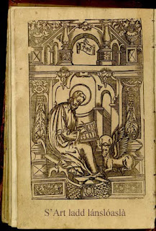
by Ayndryl on Thursday, December 03, 2009
Labels Ladd cryptolect

